Validation Summary/Overview

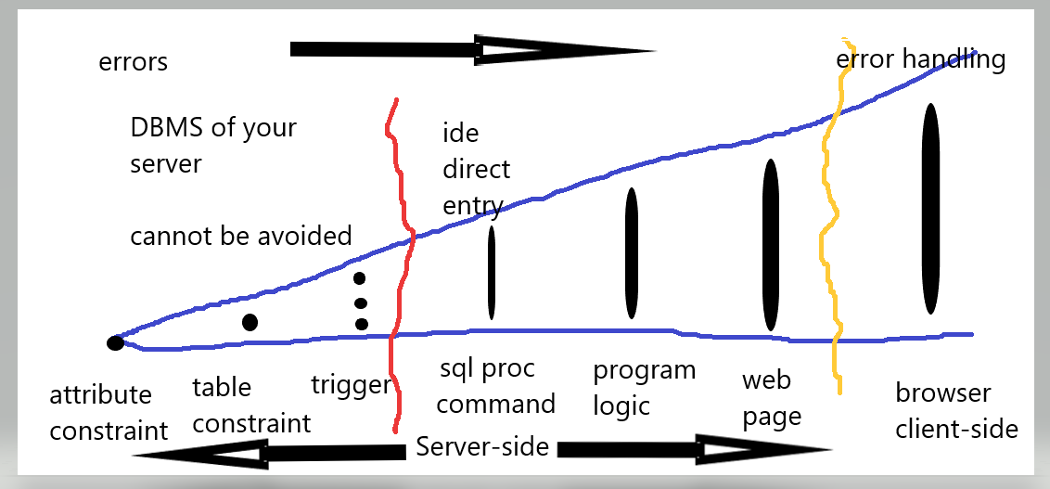

Kinds of Validation

* Client side
* Application (within your application library: services)
* Dara integrity (database)

Data Integrity

* No missing pieces
* Minimum correct structure of data
* Minimum insert/update/delete mangling of data

BLL Services (Application)

* Enforces Business rules
* Applied to business processes
* More flexible than database integrity
* Example:
  + minimum age for license
  + has all requirements to complete a transaction (sales return- invoice, item, package, warrantee
  + multiple levels of previous experience

Client Side

* improve the user experience (UX)
* primitive rules
  + required
  + datatype
  + range